**Hierarchical Memory and Principles of Advanced Computing**

By, Miss Divya Pravin Davane (SE AIDS)

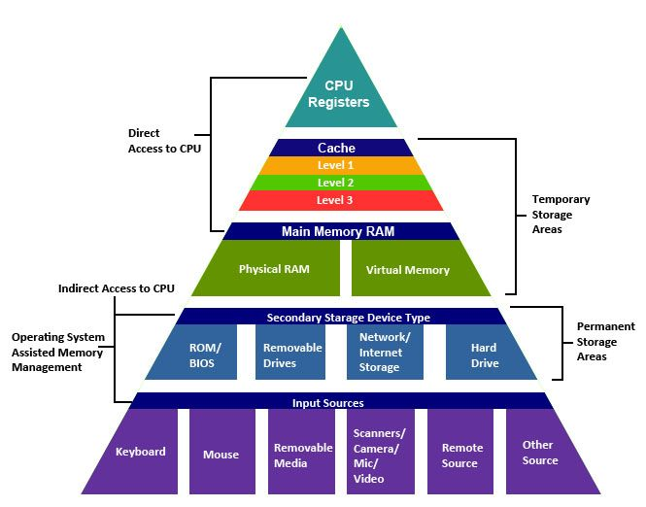In the ever-evolving field of computer science, the design and architecture of computing systems play a pivotal role in performance and efficiency. Two critical concepts in this domain are hierarchical memory and principles of advanced computing. Understanding these principles helps developers optimize performance and resource utilization in various applications, from personal computing to large-scale data centers..

Hierarchical memory refers to the organization of computer memory into different levels that balance speed, capacity, and cost to optimize overall system performance. At the top of this hierarchy are **registers**, which are small, fast storage locations within the CPU, holding data and instructions that the processor is currently using. Registers provide the quickest access times, measured in nanoseconds, but are limited in size. Next in the hierarchy is **cache memory**, which is designed to store frequently accessed data to reduce the time it takes to retrieve information from slower memory types. Cache memory is divided into multiple levels: **L1 cache** is the smallest and fastest, located closest to the CPU; **L2 cache** is larger and slightly slower; and **L3 cache**, which can be shared among CPU cores, provides a larger pool of data at a lower speed than L1 and L2. Following cache memory is the **main memory (RAM)**, which is larger but slower than cache. RAM serves as the primary storage for data and applications that are actively in use, with access times in tens of nanoseconds and capacities ranging from gigabytes to terabytes. Below RAM in the hierarchy is **secondary storage**, including hard disk drives (HDDs) and solid-state drives (SSDs). While significantly larger—often up to several terabytes—secondary storage is much slower, with access times in milliseconds. Finally, **tertiary storage** is used for long-term data storage and backup, such as magnetic tapes or cloud storage, which can handle petabytes of data but have the slowest access times, often measured in seconds or minutes.

# Hierarchical Memory

## Hierarchical memory refers to the organization of memory systems into layers based on their speed, capacity, and cost. This structure aims to balance the trade-offs between performance and resource expenditure. The memory hierarchy typically consists of the following levels:

## Registers:

## Located within the CPU, registers are the fastest form of memory. They hold

## Speed: Nanoseconds (ns).

## Size: Usually a few bytes to a few kilobytes

## 2. Cache Memory:

## Cache memory is a smaller, faster type of volatile memory that stores frequently accessed data to reduce latency. It is divided into levels:

## L1 Cache: Closest to the CPU core, very fast, but small in size (typically 32KB to 256KB).

## L2 Cache: Larger than L1 but slower, ranging from 256KB to several megabytes.

## L3 Cache: Shared among cores, even larger, used to improve data access speeds for multi-core processors.

## 3. Main Memory (RAM):

## This is the primary volatile storage area for data and programs currently in use. RAM is slower than cache but significantly larger.

## Speed: Tens of nanoseconds.

## Size: Ranges from a few gigabytes to several terabytes in high-end systems.

## 4.Secondary Storage:

## Non-volatile storage such as hard drives (HDDs) and solid-state drives (SSDs) that retain data even when powered off. They have much larger capacities but are slower than RAM.

## Speed: Milliseconds (ms).

## Size: Ranges from hundreds of gigabytes to multiple terabytes.

## 5.Tertiary Storage:

## Used for long-term data storage and backup, including magnetic tapes and cloud storage. It offers the highest capacity but the slowest access time.

## Speed: Seconds to minutes.

## Size: Can reach petabytes.

## Principles of Hierarchical Memory

## Locality of Reference:

## Programs tend to access a small, localized area of memory repeatedly. This principle is split into two categories:

## Temporal Locality: Recently accessed data is likely to be accessed again shortly.

## Spatial Locality: Data located near recently accessed memory addresses is likely to be accessed soon.

## Trade-offs:

## Faster memory types are more expensive and smaller, leading to the need for a hierarchy that combines speed, size, and cost. The goal is to keep the most frequently accessed data in the fastest levels of memory.

**Principles of Advanced Computing**

Parallelism

1. Definition:
   * Parallelism involves dividing tasks into smaller subtasks that can be executed simultaneously to enhance computational speed and efficiency.
2. Types:
   * Data Parallelism: Similar operations applied to different data elements, common in graphics processing and scientific computing.
   * Task Parallelism: Different tasks or processes run concurrently, improving performance in multi-threaded applications.

Concurrency

* Concurrency allows multiple processes or threads to run during overlapping periods, facilitating better utilization of CPU resources. It is essential in modern applications where responsiveness and resource efficiency are critical.

**Distributed Computing**

* Distributed computing involves multiple interconnected systems working together to perform complex tasks. It enhances reliability and performance by distributing workloads across multiple machines, allowing for more efficient processing and fault tolerance.

**Algorithms and Complexity**

* Efficient algorithms are vital for optimizing performance. The study of time and space complexity helps identify the most suitable algorithm for a given problem, ensuring that resources are utilized effectively.

**Fault Tolerance**

* Fault tolerance refers to the ability of a system to continue operating correctly even in the presence of faults. This is crucial in mission-critical applications where downtime can lead to significant losses.

**Scalability**

* Scalability ensures that a system can handle growth, either by upgrading existing resources (vertical scaling) or adding more machines (horizontal scaling). This flexibility is vital for accommodating increasing workloads in various applications.

**Conclusion**

Hierarchical memory and the principles of advanced computing are essential components of modern computing systems. Understanding these concepts allows for the design of more efficient, responsive, and scalable applications. As technology continues to evolve, these principles will remain foundational in shaping the future of computing architecture.